8. AIM

**Use HTML5 for performing following tasks:**

1. Draw a square using HTML5 SVG , fill the square with green color and make 6px brown stroke width
2. Write the following mathematical expression by using HTML5 MathML. d=x2-y2
3. Redirecting current page to another page after 5 seconds using HTML5 meta tag

**HTML Code**

<!DOCTYPE html>

<html>

<head>

<meta charset="utf-8" />

<title>HTML5 Demo</title>

<meta http-equiv="refresh" content="5; URL=http://www.vtu.ac.in">

</head>

<body>

<h3>HTML5 SVG</h3>

<svg width="200" height="200" align="centre">

<rect x="50" y="50" width="100" height="100" fill="green" stroke="brown" stroke-width="6px"/>

</svg>

<h3>HTML5 MathML</h3>

<math xmlns = "http://www.w3.org/1998/Math/MathML">

<mrow>

<msup><mi>d</mi></msup>

<mo> = </mo>

<msup><mi>x</mi><mn>2</mn></msup>

<mo>-</mo>

<msup><mi>y</mi><mn>2</mn></msup>

</mrow>

</math>

<h3>This page redirects in 5 seconds</h3>

</body>

</html>

**Output**

[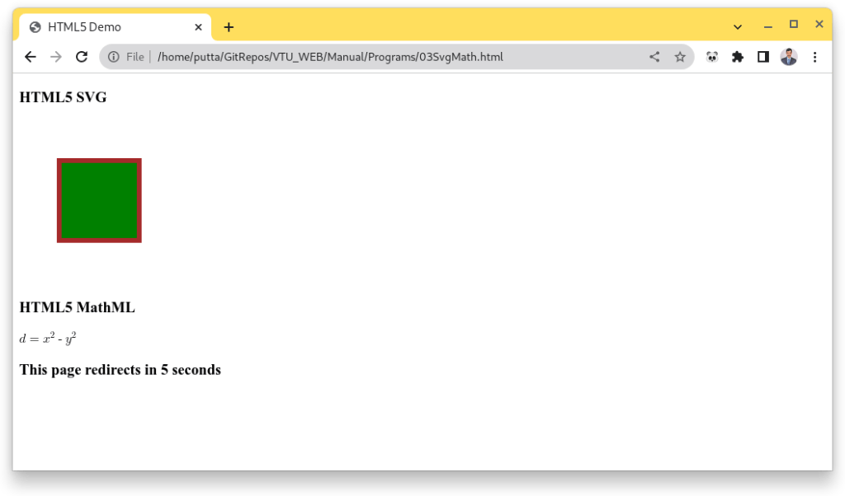](https://i0.wp.com/moodle.sit.ac.in/blog/wp-content/uploads/2023/07/03a.png?ssl=1)

**9.AIM**

**li Tag**

**Change the tag li to have the following properties:**

* A display status of inline
* A medium, double-lined, black border
* No list style type

Add the following properties to the style for li:

* Margin of 5px
* Padding of 10px to the top, 20px to the right, 10px to the bottom, and 20px to the left

Also demonstrate list style type with user defined image logos

**HTML Code**

<!DOCTYPE html>

<html>

<head>

<meta charset="utf-8" />

<title>Tag Properties </title>

<style>

.custom {

display: inline;

border: 2px double black;

list-style-type: none;

margin: 5px;

padding-top: 10px;

padding-right: 20px;

padding-bottom: 10px;

padding-left: 20px;

}

.logo {

list-style-image: url('https://www.w3schools.com/cssref/sqpurple.gif');

margin: 15px;

}

</style>

</head>

<body>

<h2>li Tag Property modification Demo</h2>

<h3>Current Top FootBall Players</h3>

<ul>

<li class="custom">Lionel Messi</li>

<li class="custom">Kylian Mbappe</li>

<li class="custom">Lewandowski</li>

</ul>

<br>

<h2>list style type with user defined image logos</h2>

<h3>Current Top FootBall Goalkeepers</h3>

<ul class="logo">

<li>Emiliano Martinez</li>

<li>Thibaut Courtois</li>

<li>Yassine Bounou</li>

</ul>

</body>

</html>

**Output**

[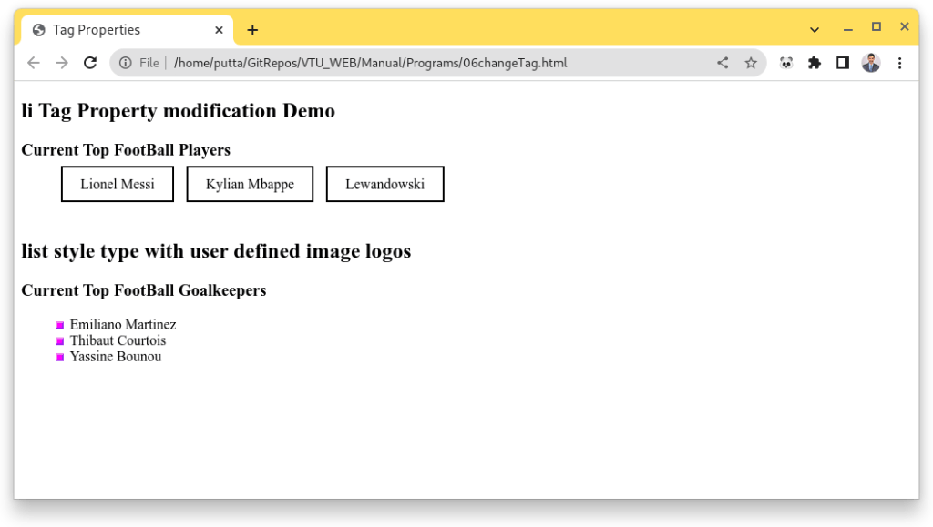](https://i0.wp.com/moodle.sit.ac.in/blog/wp-content/uploads/2023/07/06a.png?ssl=1)

**10.AIM**

**Calculator**

**Create following calculator interface with HTML and CSS**

[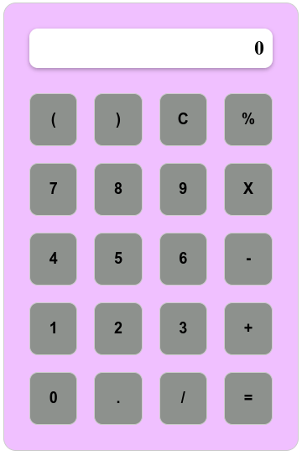](https://i0.wp.com/moodle.sit.ac.in/blog/wp-content/uploads/2023/07/08b.png?ssl=1)

**HTML Code**

<!DOCTYPE html>

<html>

<head>

<meta charset="utf-8" />

<title></title>

<link rel="stylesheet" type="text/css" href="calcstyle.css">

</head>

<body>

<div class="calculator">

<div class="display">

<p id="result">0</p>

</div>

<div class="buttons">

<button onclick="appendToDisplay('(')">(</button>

<button onclick="appendToDisplay(')')">)</button>

<button onclick="clearDisplay()">C</button>

<button onclick="appendToDisplay('%')">%</button>

<button onclick="appendToDisplay('7')">7</button>

<button onclick="appendToDisplay('8')">8</button>

<button onclick="appendToDisplay('9')">9</button>

<button onclick="appendToDisplay('*')">X</button>

<button onclick="appendToDisplay('4')">4</button>

<button onclick="appendToDisplay('5')">5</button>

<button onclick="appendToDisplay('6')">6</button>

<button onclick="appendToDisplay('-')">-</button>

<button onclick="appendToDisplay('1')">1</button>

<button onclick="appendToDisplay('2')">2</button>

<button onclick="appendToDisplay('3')">3</button>

<button onclick="appendToDisplay('+')">+</button>

<button onclick="appendToDisplay('0')">0</button>

<button onclick="appendToDisplay('.')">.</button>

<button onclick="appendToDisplay('/')">/</button>

<button onclick="evaluate()">=</button>

</div>

</div>

</body>

</html>

**CSS Code**

.calculator {

display: flex;

flex-direction: column;

width: 350px;

margin: 10px;

border: 1px solid #ccc;

border-radius: 15px;

background-color: #F0C0FF;

}

.display {

background-color: #fff;

border-radius: 10px;

box-shadow: 0px 2px 5px rgba(0, 0, 0, 0.3);

display: flex;

justify-content: flex-end;

align-items: center;

padding: 10px;

margin-left: 30px;

margin-right: 30px;

margin-top: 30px;

}

.buttons {

display: grid;

grid-template-columns: repeat(4, 1fr);

padding: 20px;

}

button {

padding: 20px;

background-color: #8D918D;

border: 1px solid #ccc;

border-radius: 10px;

cursor: pointer;

margin: 10px;

font-size: 18px;

font-weight: bold;

}

button:hover {

background-color: #d9d9d9;

}

button:active {

background-color: #bfbfbf;

}

#result {

margin: 0;

font-size: 24px;

font-weight: bold;

}

**Output**

[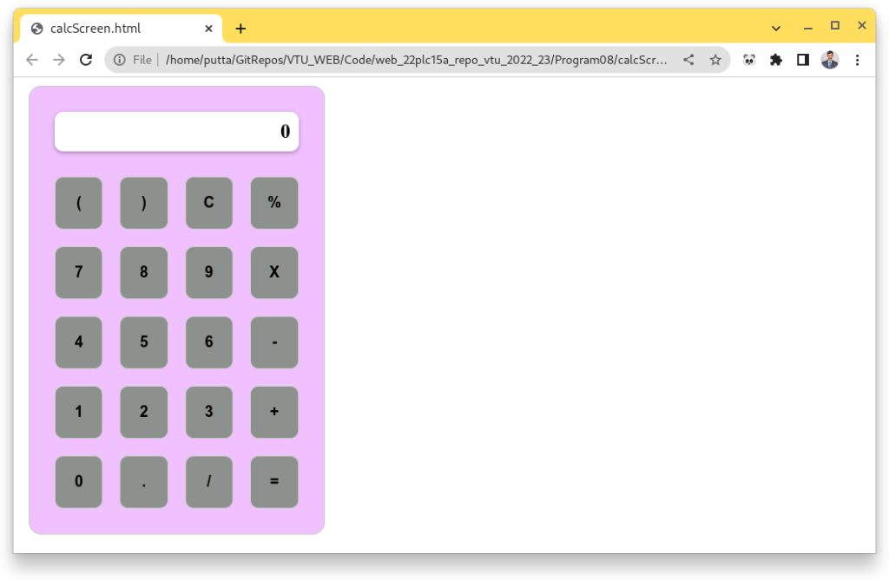](https://i0.wp.com/moodle.sit.ac.in/blog/wp-content/uploads/2023/07/08a.png?ssl=1)